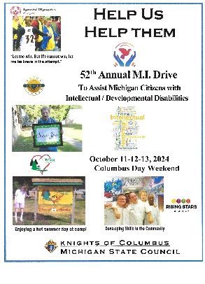
Palm Sunday Weekend MI Drive
March 27-29, 2026

Alternate Dates: March 20-22 and April 10-12, 2026

Report & Check Due to MI State Director by: May 25, 2026

Insurance Binder will be e-mailed to the Grand Knight, District Deputy & Financial Secretary via the Gmail mikofc.org account and posted online 30 days before the drive.

Forms & Supplies:
www.MiKofC.org / Resources / Community/ MI Drive
MI-13 Intellectual Disabilities Drive Work Sheet MI-13
MI-13a Tootsie Roll Order Form MI 13a
MI-13c MI Drive Liability Insurance Cert MI 13c

Special Needs Vests – Now order through Knights Gear, Supplies online no longer sells them.
Go through Knightsgear.com, CPID vests cost $19.95 each

Questions or Problems Contact:
Mark Brezenski – State MI Program Director
Phone (248) 227-8120 or e-mail: m.brezenski@mikofc.org
Insurance
Mark Brezenski – State MI Program Director
Phone (248) 227-8120 or e-mail: m.brezenski@mikofc.org
Do Not Call the Policy Insurer

Tootsie Roll Orders
Maureen Fadden – (708) 423- 5193 at least 6 weeks prior to the Drive

Steps for a Successful Drive
- Appoint Chairmen
- Check vests & canisters – Equipment with “Mentally Retarded” on them may not be used
- Order vests and Tootsie Roll supplies before February 1, 2026, (at least six weeks before the drive)
- Request permission/permits to solicit from localities and businesses before the event
- Meet with your pastor for approval if you are soliciting at your church
- If soliciting in roads, safety approved vests (ANSI Type 2), must be worn.
- Decide before the drive, which agencies will receive the funds collected
  - Are they appropriate? (Intellectual/Developmental Disability only)
- Schedule sufficient workers for times and locations
- Submit report form and check within 30 days of the drive on the current MI-13 Drive Work Sheet found on State website (details above)
- Deliver checks as soon as the Financial Secretary receives them – checks void after 180 days

Helping People with Intellectual/Developmental Disabilities

